|  |
| --- |
| **PROJECT REPORT TEMPLATE** |

**Implementing CRM for Result tracking of a candidate with internal marks**

**1. INTRODUCTION**

* 1. Overview:

Administrator should be able to create all base data including Semester, Candidate, Course and Lecturer, Lecturer should have the ability to create Internal Results, Dean, who is one of the Lecturer, should be the only one with ability to update Internal Results, Re-evaluation Can be initialized by Candidate for all Internal Results. Now only dean can update the marks after re-evaluation.

* 1. Purposes:

1] It helps you in collating all the customer information at one place and helps you in better customer management.

2] A want is placing certain personal criteria as to how that need must be fulfilled.

3] It is easy way to maintain internal marks.

**2. PROBLEM DEFINITION & DESIGN THINKING**

2.1. Empathy Map

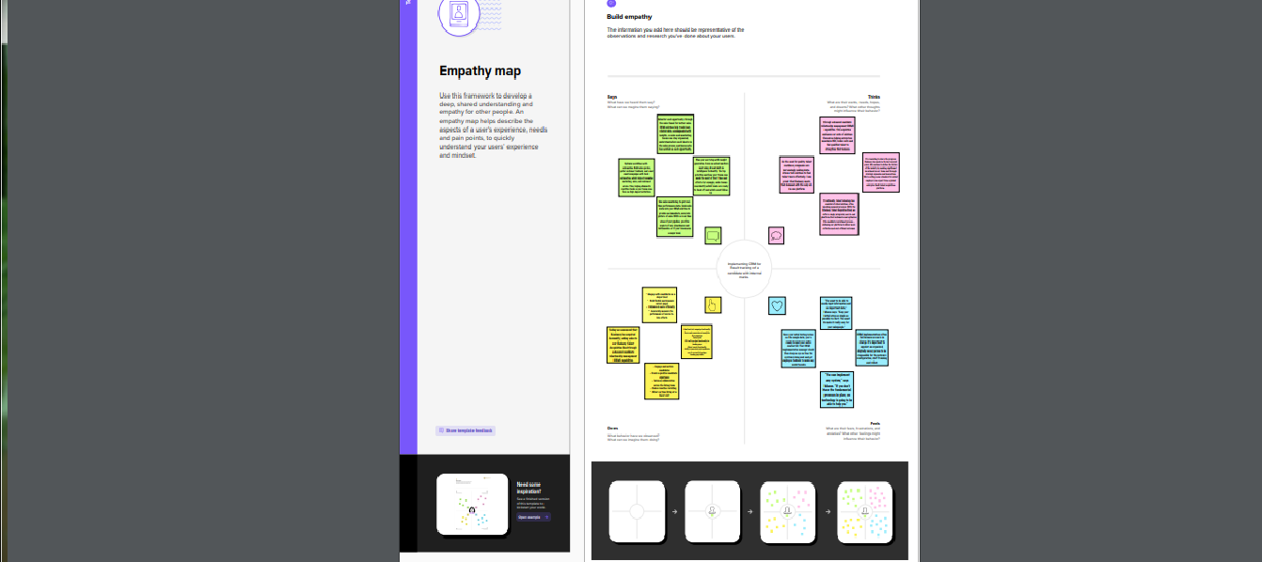

2.2. Ideation & Brainstorming Map

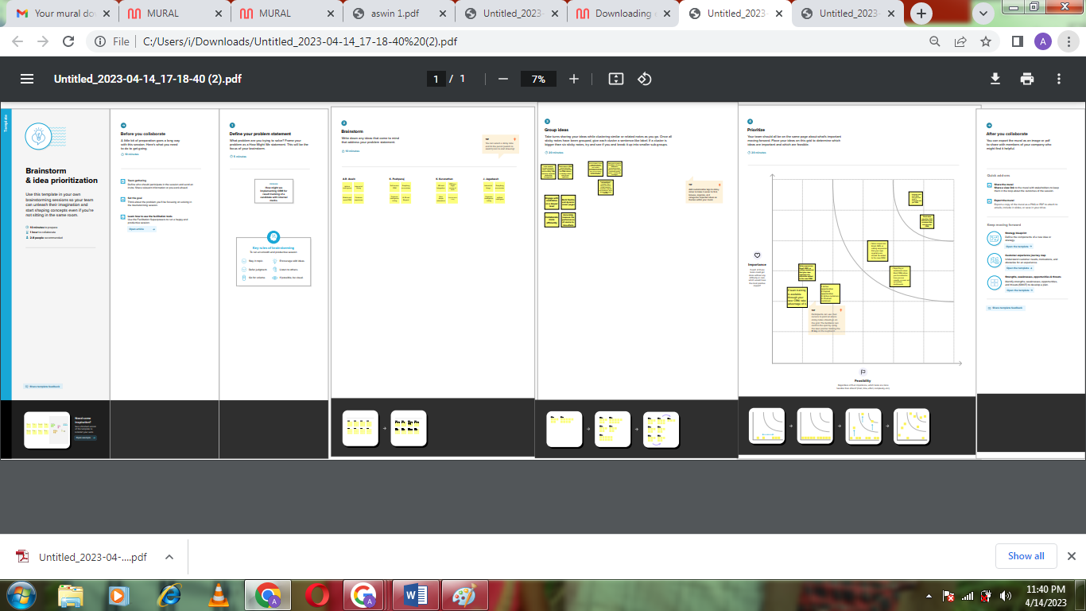

**3. RESULT:**

**3.1 Data Model**:

|  |  |
| --- | --- |
| **OBJECT NAME** | **FIELDS IN THE OBJECT** |
| **SEMESTER** | FIELD LABEL:  Semester Name  Course(Lookup)  DATA TYPE:    Text |
| **CANDIDATE** | FIELD LABEL:    Candidate Name  Candidate ID  Semester Name  Internal Result(Lookup)  DATA TYPE:  Text |
| **COURSE DETAILS** | FIELD LABEL:  Course Name  Course ID  DATA TYPE:  Text |
| **LECTURER DETAILS** | FIELD LABEL:  Lecturer Roll  Lecturer Name  Course ID  Course(Lookup)  DATA TYPE:  Text |
| **INTERNAL RESULTS** | FIELD LABEL:  Candidate ID  Course ID  DATA TYPE:  Text |

3.2. Activity And Screenshot:

Milestone 1: Creating developer account

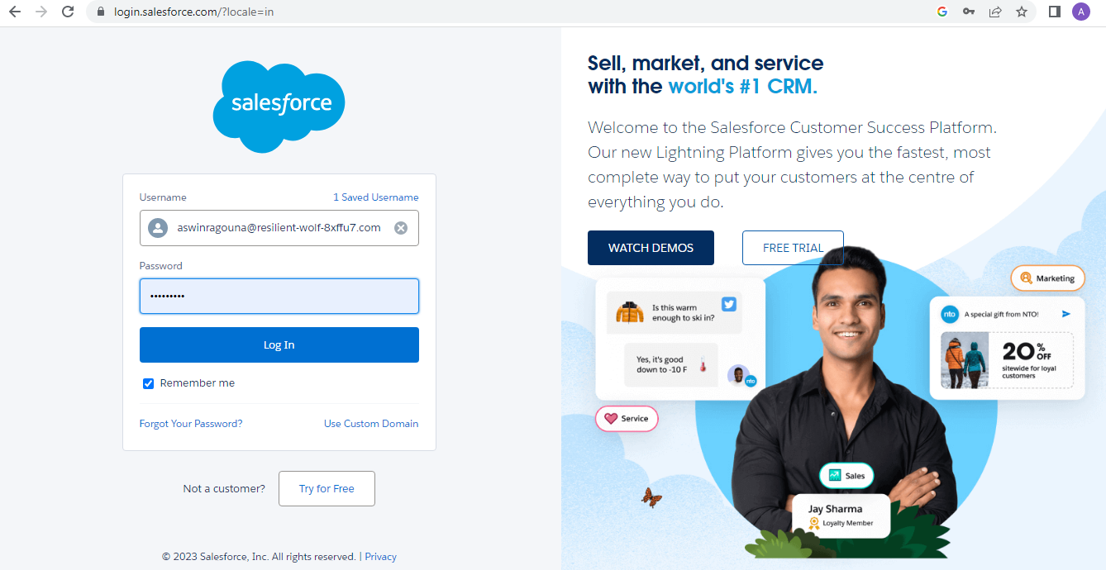

Activity 1: To create an object

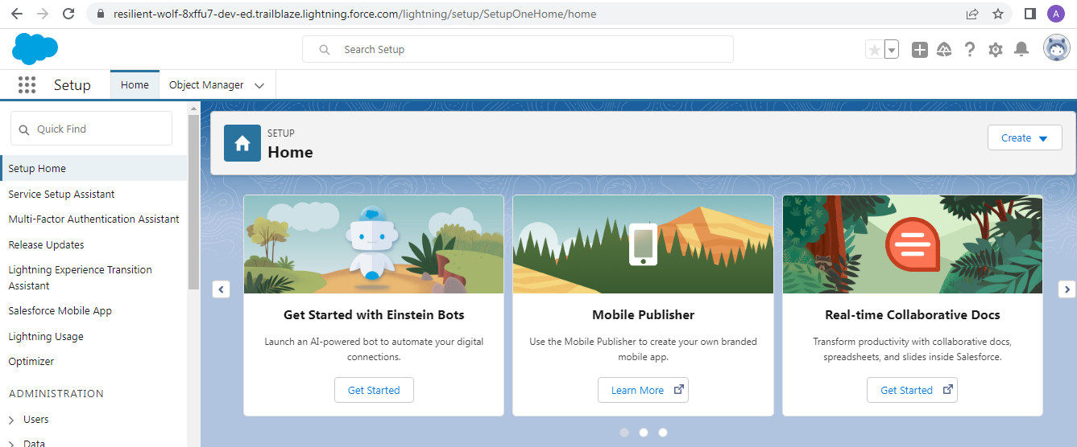

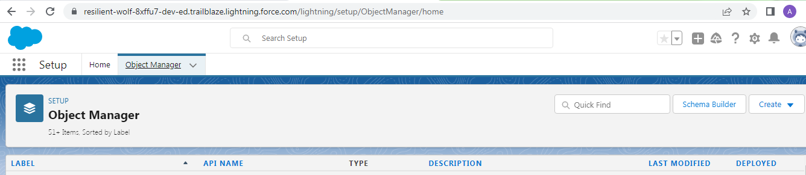

Milestone 2: Fields and Relationship

Activity 1: Creation of fields:

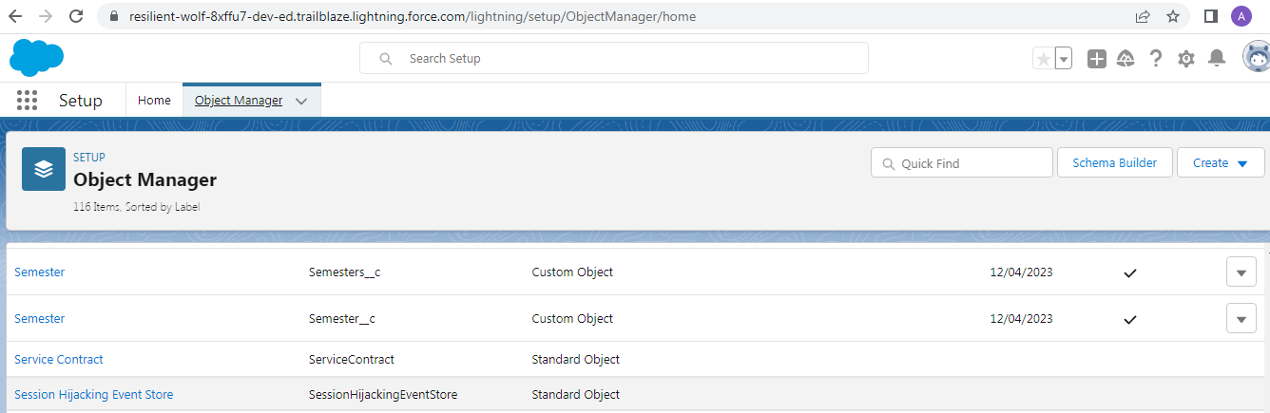

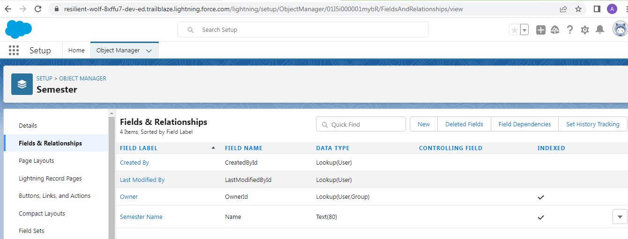

Milestone 3: Lightning App

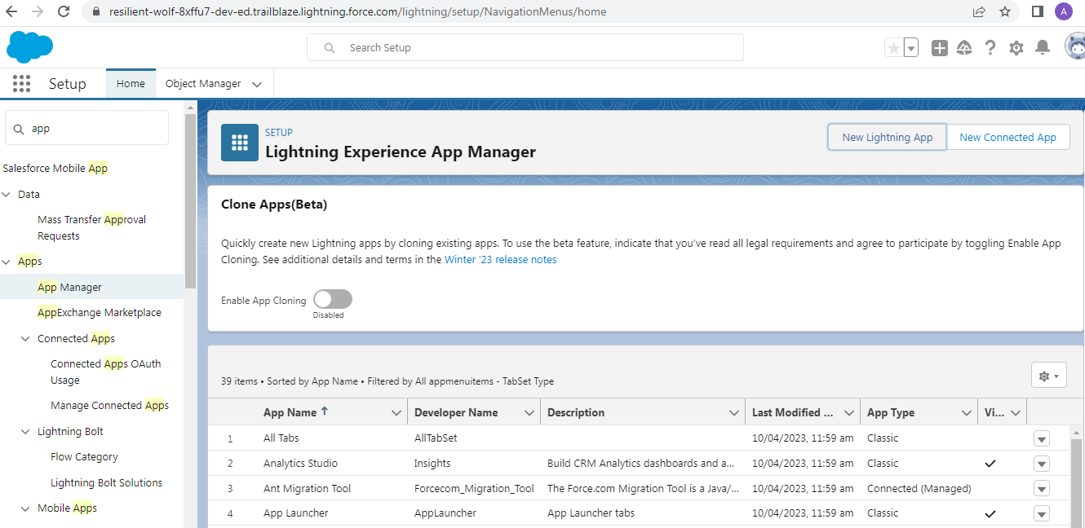

Milestone 4: User

Activity 1: creating a useres

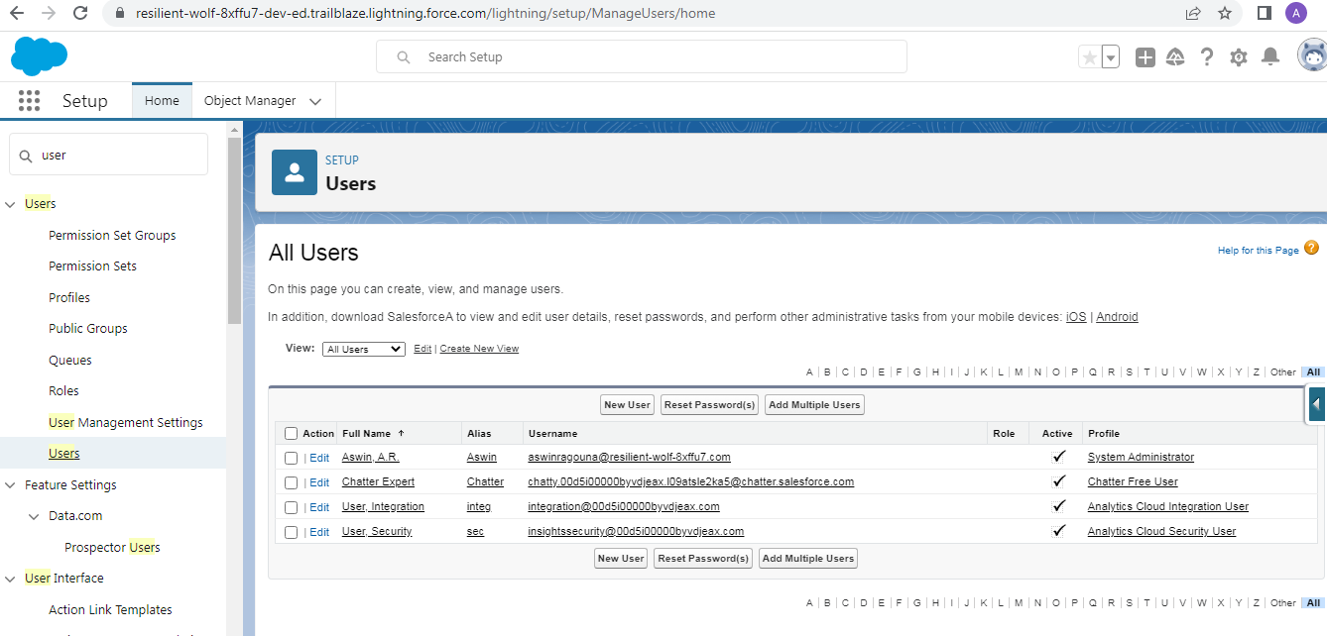

Milestone 5: Reports

Activity 1: Reports and dashboards:

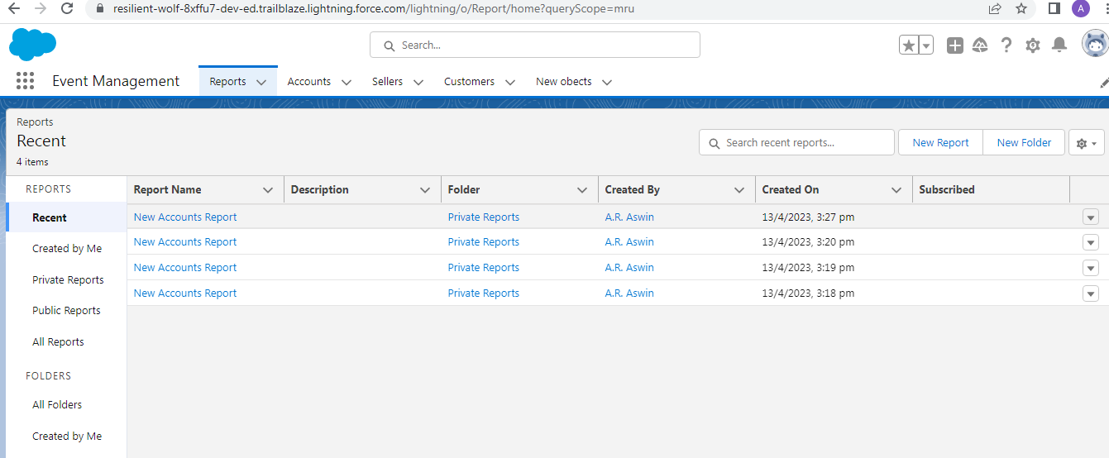

Milestone-6 Dashboards:

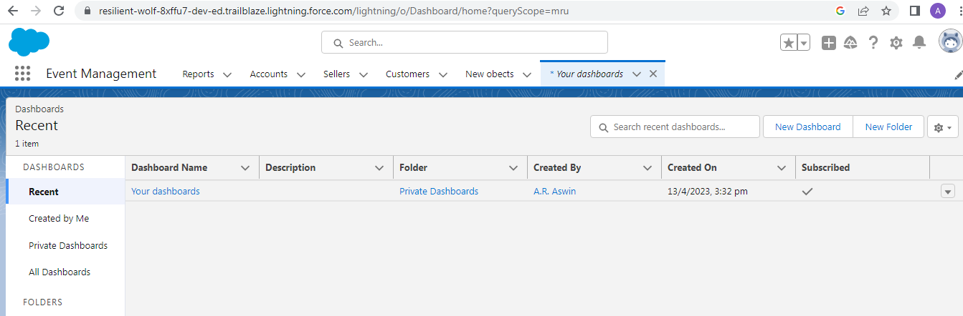

**4. Trailhead Profile Public URL**

Team Lead - <https://trailblazer.me/id/aaswin17>

Team Member 1- <https://trailblazer.me/id/pushparaj30>

Team Member 2- <https://trailblazer.me/id/jagadeeshjaga>

**5.** **ADVANTAGES & DISADVANTAGE**

**Advantage:**

* It allows for more effective sales and marketing
* It can speed up the sales conversion process.
* It increases staff productivity, lowers time costs and boosts morale.
* It enables widely dispersed teams to work closely.
* Can improve customer loyalty through exceptional experience.

**Disadvantage:**

* Security concerns associated with centralized data.
* The excess initial time and productivity cost of implementation.
* It requires a process-driven sales organization.
* It may not suit every business.
* Staff over-reliance on CRM may diminish customer loyalty through a bad experience.

**6. Application**

* I want something reliable
* Target marketing
* Increase candidate quality
* Can work easily
* Streamlining internal sales processes

**7. CONCLUSION**

Student Internal Mark Management System deals with student details, academic related reports, college details and course details. It tracks all the details of a student from the day one to the end of his course which can be used for all reporting purpose, tracking of progress in the course, completed semester, upcoming semester details, exam details, project or any other assignment details, and final exam result.

**8. FUTURE SCOPE**

Scope of education means range of view, outlook, field or opportunity of activity operation and application of education. Education has a wider meaning and application.